Baird, Irene. (1901-1981)

Thumbnail:

Canadian novelist and civil servant Irene Baird is best known for her second novel, *Waste Heritage* (1939) which was based on first-hand research into the Vancouver “sit down strike” of the unemployed in 1938. *Waste Heritage* was remarkable in its time for its use of colloquial idioms, its realist representation of the lives of the unemployed, and its naturalist approach to sexuality and violence. Often cited as the best Canadian novel of the Depression era, *Waste Heritage* was nonetheless a financial failure for Baird, and she sought a more reliable source of income writing promotional material and lecturing for the National Film Board during WW II, spending the balance of her career as a civil servant based in Ottawa.

Main entry:

Irene Baird was born Irene Violet Elise Todd, in Cumberland County, England and immigrated with her family to Vancouver Island in 1919. There she met Robert Patrick Hay Baird, an engineer, and the couple settled in Vancouver where they raised two children and Baird taught school. Her first novel, *John*, appeared in 1937 to much acclaim; it follows the life of a British immigrant to Canada who maintains a quiet life of integrity and connection to the land in opposition to the values of a shoddy urban modernity. Praised for its prose style and character development, *John* has little structure, and so demonstrates Baird’s major flaw as a novelist: like her character Kenny in *Waste Heritage*, she finds it difficult to impose plot on her material, which consequently seems to go “in one end, round an’ round, out the same end.”

Baird was excited by the prospect of researching *Waste Heritage*, a book about the Vancouver protests of the unemployed against the closure of government work camps. The book follows Matt Striker, an everyman character, who arrives in Vancouver in the wake of the “bloody Sunday” riot (June 19, 1938), and joins with the protestors in a march from Vancouver to the provincial legislature in Victoria to confront the Premier of the province. Matt befriends a striker, Eddy, who has suffered severe head trauma in his encounter with police and who has become violent and unpredictable as a result. The novel represents the themes of modernity, such as the tension between individuality and mob culture, the loss of traditional connection to place, and the problem of industrialization of work, using a realist aesthetic typical of Canadian modernist fiction, heavily influenced by European and US naturalism and utilizing a stripped down, journalistic prose. While stylistically conservative in the context of international modernism, Baird’s work is recognized as characteristic of Canadian modernist fiction, which “sought a direct, immediately, contemporary, idiomatically correct language, and a narrative objectivism and impersonality” along with “sustained and experimental interest in psychological writing and the representation of human consciousness” (Hill xxx).

The manuscript of *Waste Heritage* was accepted with enthusiasm by Hugh Eayrs on behalf of the Toronto branch of MacMillan publishers, who perceived it as topical as well as stylistically ground-breaking. But the outbreak of the war in 1939 made the novel’s seeming sympathy with the politics of the strikers problematic, and references to the authorities as behaving “like Nazis” were censored at the direct request of O. D. Skelton, undersecretary of state for external affairs. Baird had aimed at journalistic objectivity in the novel, but the perception of the novel as a “leftist” book haunted Baird through her subsequent career with the federal government, especially in the red-baiting 1950s. *Waste Heritage* did not appear until after the beginning of WW II, when the fight of the “sit-downers” was old news, and Baird quickly began a project that was more timely, an epistolary novel about a pilot engaged in the fight against Germany. *He Rides the Sky* was also a financial failure, and Baird approached John Grierson of the National Film Board for a job doing “war work.” Her final novel, *Climate of Power,* appeared after her retirement from the civil service and is based on her experiences in the department of Northern Affairs. Her extensive travel in the North also resulted in poems and essays published late in her career.

List of Works

*John* (1937)

*Waste Heritage* (1937)

*He Rides the Sky* (1941)

*Climate of Power* (1971)

Further Reading

Hill, Colin. “Introduction” *Waste Heritage* by Irene Baird. Critical edition prepared by Colin Hill, University of Ottawa Press, 2007.

Mason, Jody. “State Censorship and Irene Baird's *Waste Heritage.*”

[*Canadian Literature*](http://search.proquest.com.ezproxy.library.uvic.ca/pubidlinkhandler/sng/pubtitle/Canadian+Literature/$N/47638/DocView/218823930/fulltext/39F66E9EC5CE4FEEPQ/1?accountid=14846)[191](http://search.proquest.com.ezproxy.library.uvic.ca/indexingvolumeissuelinkhandler/47638/Canadian+Literature/02006Y12Y01$23Winter+2006$3b++$28191$29/$B/191?accountid=14846) (Winter 2006): 192-195,202.

Sangster, Joan. “Creating a Writer’s Archive: Irene Baird’s Work and Travel,

1940-1967.” *Journal of Historical Biography,* 10:1 (November 2011) 34-69.

Paratextual material

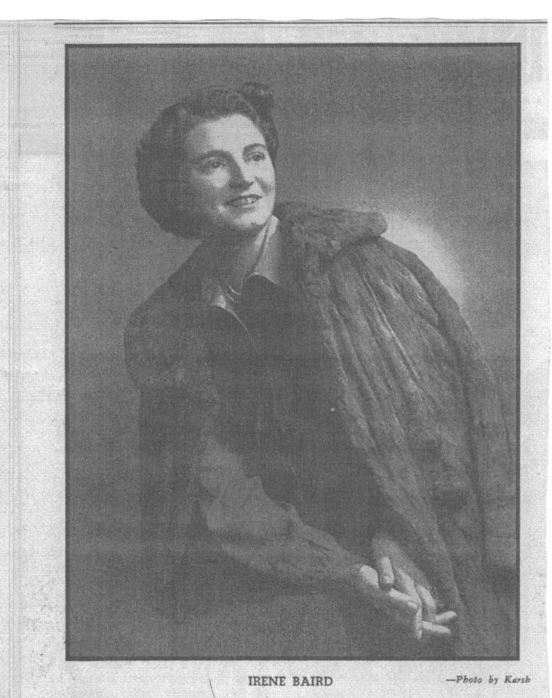

Irene Baird photo by Karsh, reprinted in “Names in the News: Novelist Goes to the Films” Saturday Night, 9 January 1943.

public domain images of the sit-down strike available at the Vancouver public library, search page: <http://www3.vpl.vancouver.bc.ca/spe/histphotos/histPhotoAdvancedSearch.html>

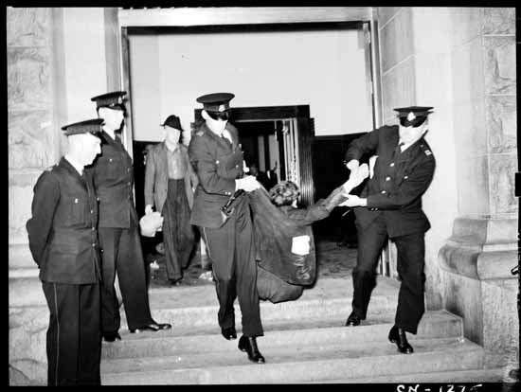

Police removing strikers from the Vancouver post office June 11 1938. Photo taken by the Province Newspaper. Public Domain. VPL Accession Number: 1275

“Censorship in Canada” by [Pearce J. Carefoote](http://hpcanpub.mcmaster.ca/users/pcarefoote), *Historical Perspectives on Publishing in Canada* <http://hpcanpub.mcmaster.ca/case-study/censorship-canada>. Images of letters related to the censorship of the book. (I can’t figure out how to download these images and attach them to this file.)